Wenjie Lab 3

1. What is the TCP port number used by your computer to communicate with gaia.cs.umass.edu?

Answer: The TCP port number of my computer is 55026

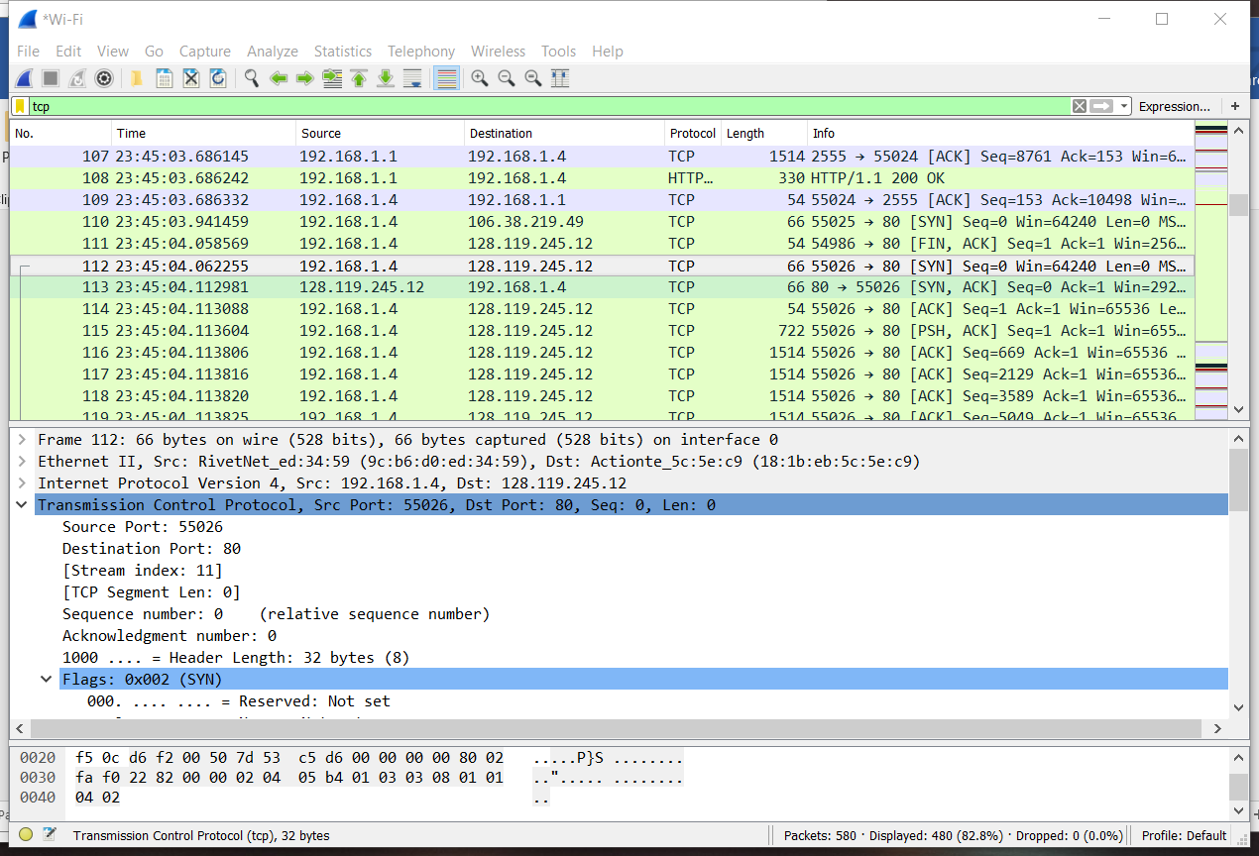

2. What is the TCP port number used by gaia.cs.umass.edu to communicate with your computer?

Answer: The TCP port number of gaia website is 80



3. What is the sequence number of the TCP SYN segment that is used to initiate the TCP connection between your computer and gaia.cs.umass.edu? What is it in the segment that identifies the segment as a SYN segment?

Answer: The sequence number of the TCP SYN segment is 0.

In the flags section, the SYN flag showing set to 1 is used to identify SYN segment.

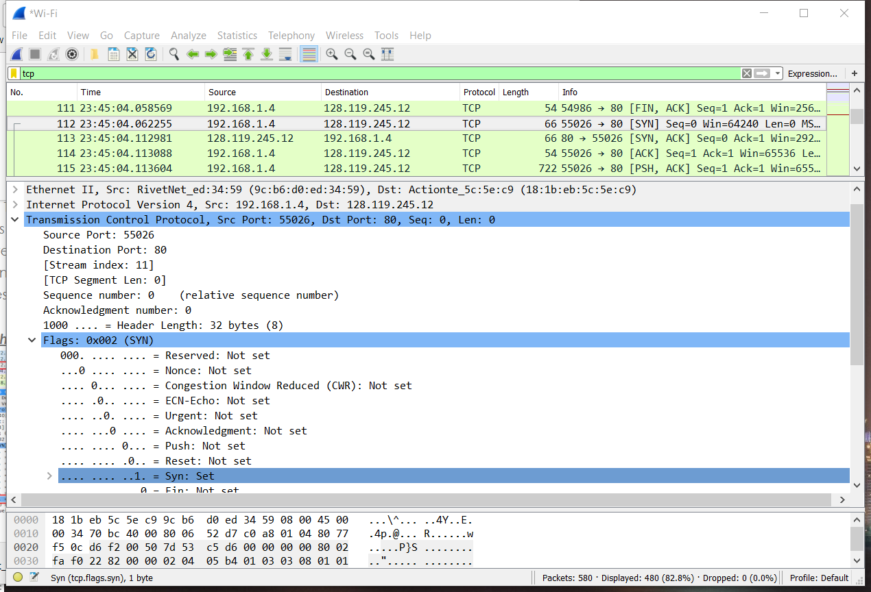

4. What is the sequence number of the SYNACK segment sent by gaia.cs.umass.edu to the client computer in reply to the SYN? - You must dig deep and find the ACK from gaia.cs.umass.edu.

Answer: The sequence number of the SYNACK segment sent by gaia website is 0.

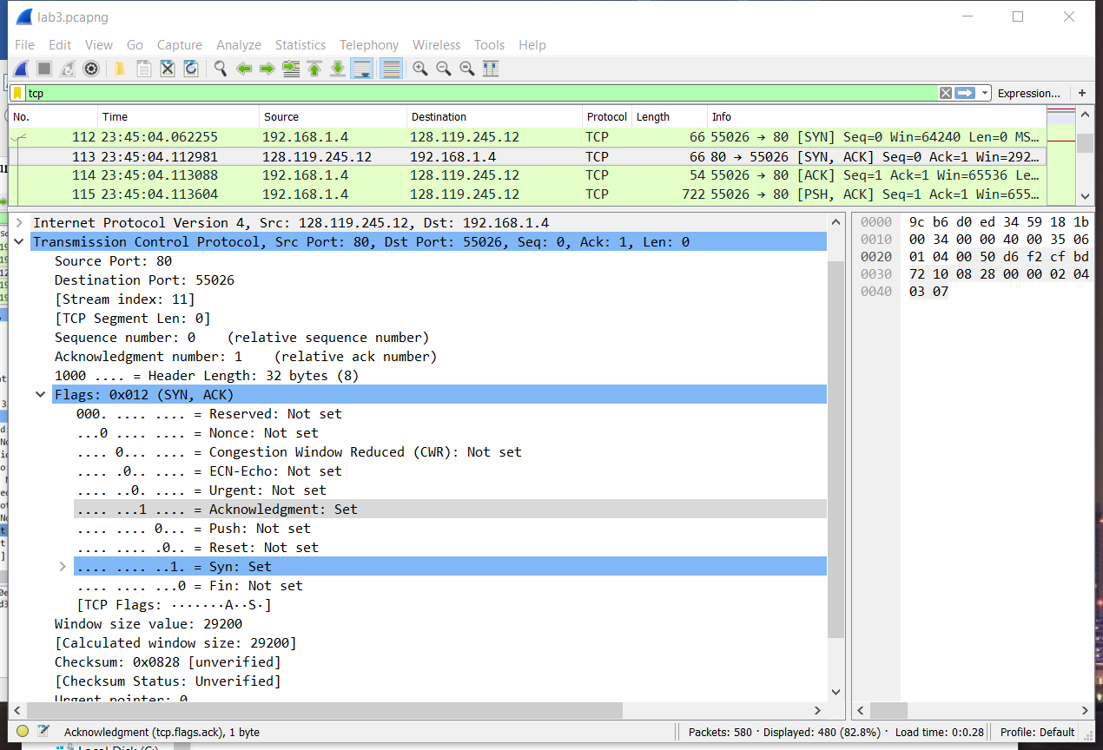

5. What is the sequence number of the TCP segment containing the HTTP POST command? Note: that to find the POST command, you’ll need to dig into the packet content field at the bottom of the Wireshark window, looking for a segment with a “POST” within its DATA field.

Answer: The sequence number of the TCP segment with the HTTP POST command is 151593

